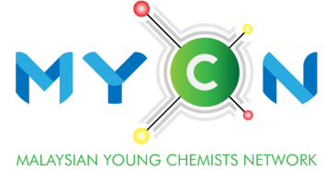**Outstanding**

**Young Chemist Award**

**(Industry)**

|  |  |
| --- | --- |
| YEAR : |  |

**APPLICATION FORM**

Kindly review the eligibility criteria and application details before submission. Submit the form in pdf format. It is mandatory for all submissions by **31st Jul each calendar year**.

|  |  |  |  |  |
| --- | --- | --- | --- | --- |
| **Particulars of Applicant** | | | | (Photo) |
| Full Name  *(Prof./Assoc. Prof./ Dr./Mr./Ms.)* |  | | |
| Age |  | | |
| Date of Birth |  | | |
| Position/Affiliation |  | | | |
| Academic/ Professional Qualification  (full details) |  | | | |
| IKM Membership No. |  | | | |
| Years of working experience |  | | | |
| Email |  | | | |
| Contact number |  | | | |
| By submitting this application, I certify that**:**   |  | | --- | | * I have provided true, complete, accurate information in my application and related documents, and I have represented myself/ourselves, my/our research and my/our accomplishments in a manner consistent with the norms of the relevant field. * I further understand that any false statements may result in denial or revocation of the award. * I have read, understood and agreed to abide by the Personal Data Protection Policy of IKM and MYCN. | | | | | |
| Signature |  | Date |  | |

|  |
| --- |
| **Results evaluation\*** |
| Professional training and development |
| Industrial development including human resource development, innovations, new processes and technologies, inventions, etc. |
| Service, leadership, top management and entrepreneurship. |
| Contributions to the advancement of chemistry in Malaysia and further development of Institut Kimia Malaysia. |
| **Reports / Supporting Document\*** |
| Supporting documents / reports for your involvement in the innovation / creation. |

*\*Applicants may attach relevant certificates and documents separately for each claim herein.*

**Eligibility Criteria:**

1. Applicants must be existing IKM members.
2. Applicants aged 45 years old or below in the year of application.
3. Applicants must have a minimum of 5 years of working experience.
4. Applicants must be Malaysian chemists working in chemical or chemistry related industries.