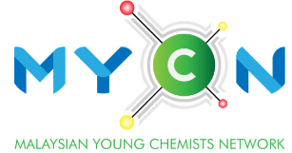**Outstanding**

**Young Chemist Award**

**(Academic)**

|  |  |
| --- | --- |
| YEAR: |  |

**NOMINATION FORM**

Kindly review the eligibility criteria and application details before submission. Submit the form in pdf format. It is mandatory for all submissions by **31st Jul each calendar year**.

|  |  |  |  |  |  |
| --- | --- | --- | --- | --- | --- |
| Name of applicant:  *(Prof./Assoc. Prof./Dr./Mr./Ms.)* |  | | | | |
| **Particulars of Nominator** | | | | | |
| Name:  *(Prof./Assoc. Prof./Dr./Mr./Ms.)* |  | | | | |
| Position/  Affiliation: |  | | | | |
| Email: |  | | | | |
| Contact number: |  | | | | |
| Signature: |  | Date: | |  | |
| **Particulars of seconder** | | | | | |
| Name:  *(Prof./Assoc. Prof./Dr./Mr./Ms.)* |  | | | | |
| Position/  Affiliation: |  | | | | |
| Email: |  | | | | |
| Contact number: |  | | | | |
| Signature: |  | | Date: | |  |

To be filled in by Nominator:

|  |
| --- |
| **Describe the timeline and your association to the nominee.** |
|  |
| **Please provide pertinent information about the nominee’s research and development capability, working attitude, education/teaching innovation, outreach programs including mass & social media, leadership, relevant experience, etc.** |
|  |