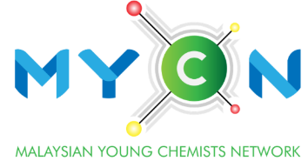
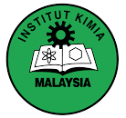
Outstanding
Young Chemist Award
(Academic)

CHECKLIST

Document Checklist | Yes | No | Comment
Completed application form
Completed nomination form
Updated curriculum vitae
Academic certificates and transcripts (highest level of education)
IKM membership certificate
Proof of publications
Proof of research grants/ intellectual properties/ awards
Proof of postgraduate student supervision
Offer letter of leadership roles

Eligibility Criteria:

- Must be an IKM member.
- Must be 45 years old or below in the year of application.
- Must have at least 5 years of working experience as an academic.
- Must be working in pure chemistry or a chemistry-related field.
- The applicant must demonstrate excellent performance in research and teaching:
- Research publications (WoS-Indexed Journal only). Only the main author (e.g. first author or corresponding author) will be considered.
- Recipient of research grants (only as the principal investigator)
- Project leader for intellectual property
- Main supervisor of postgraduate students
- Other notable contributions
- Research work submitted must have been published/accepted before the application date.
- Any claim without supporting document/ evidence shall be deemed as invalid.

