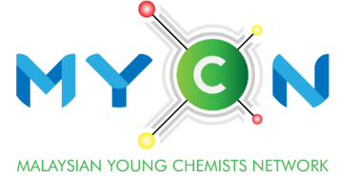
Outstanding
Young Chemist Award
(Industry)

YEAR :
NOMINATION FORM

Kindly read the eligibility and details of application before submission. Submit the nomination form (in pdf format) together with application form before 30th June 2024.

Name of applicant:
(Prof./Assoc. Prof./ Dr./Mr./Ms.)

Particulars of Nominator
Name:
(Prof./Assoc. Prof./ Dr./Mr./Ms.)
Position/Affiliation:
Email:
Contact number:
Signature: |  | Date:
Particulars of Seconder
Name:
(Prof./Assoc. Prof./ Dr./Mr./Ms.)
Position/Affiliation:
Email:
Contact number:
Signature: |  |  | Date:

To be filled in by Nominator only.
Describe the timeline and association with the nominee.
Please provide pertinent information about the nominee’s capability, working attitude, innovative leadership, relevant experience, etc.
*Nominator may attach relevant supporting documents separately for each claim herein (if any).

