Outstanding
Young Chemist Award
(Academic)
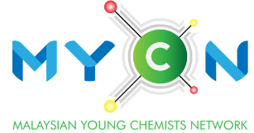
YEAR:
NOMINATION FORM

Kindly review the eligibility criteria and application details before submission. Submit the form in pdf format. It is mandatory for all submissions by 30th June each calendar year.
Name of applicant:
(Prof./Assoc. Prof./Dr./Mr./Ms.)

Particulars of Nominator
Name:
(Prof./Assoc. Prof./Dr./Mr./Ms.)
Position/
Affiliation:
Email:
Contact number:
Signature: |  | Date:
Particulars of seconder
Name:
(Prof./Assoc. Prof./Dr./Mr./Ms.)
Position/
Affiliation:
Email:
Contact number:
Signature: |  |  | Date:

To be filled in by Nominator:
Describe the timeline and your association to the nominee.

Please provide pertinent information about the nominee’s research and development capability, working attitude, education/teaching innovation, outreach programs including mass & social media, leadership, relevant experience, etc.

