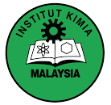
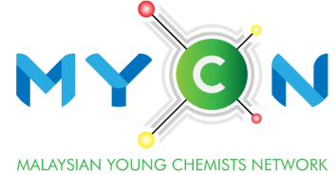
Outstanding
Young Chemist Award
(Industry)

APPLICATION CHECKLIST

Document Checklist | Yes | No | Comment
Completely filled Application Form
Completely filled Nomination Form
Updated Curriculum vitae
Academic certificates and transcripts (highest level of education)
IKM membership certificate
Supporting documents / reports for professional training & development
Supporting documents / reports for service, leadership & entrepreneurship
Supporting documents / reports for contributions to the advancement of chemistry
Supporting documents / reports for your involvement in the innovation / creation
Any other supporting document that will help for the evaluation (eg. Patent applications, technical journals, marketing materials, technical presentations, product specification etc.)

Eligibility Criteria:

- Applicants must be an existing IKM member.
- Applicants aged 45 years old or below at application year.
- Applicants must have a minimum of 5 years working experience.
- Applicants must be Malaysian chemists who work in chemical or chemistry related industries.

