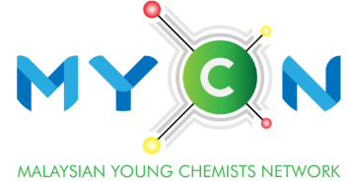
Outstanding
Young Chemist Award
(Industry)

YEAR :
APPLICATION FORM

Kindly read the eligibility and details of application before submission. Submit the form in pdf format only. Application submission dateline before 30th June 2024. Applicant should attach his/ her curriculum vitae with this form together with all relevant documents.

Particulars of Applicant |  |  |  | (Photo)
Full Name
(Prof./Assoc. Prof./ Dr./Mr./Ms.)

Age

Date of Birth

Position/Affiliation
Academic/ Professional Qualification
(full details)
IKM Membership No.
Years of working experience
Email
Contact number
By submitting this application, I certify that:
- I have provided true, complete, accurate information in my application and related documents, and I have represented myself/ourselves, my/our research and my/our accomplishments in a manner consistent with the norms of the relevant field.
- I further understand that any false statements may result in denial or revocation of the award.
- I have read, understood and agreed to abide by the Personal Data Protection Policy of IKM and MYCN.

Signature |  | Date

Outstanding contributions*
Please provide only the outstanding contributions instead of list of works/jobs you have conducted.

- Professional training and development

- Industrial development including human resource development, innovations, methods, processes, technologies, inventions, etc.

- Service, leadership, top management or entrepreneurship.

- Contributions to the advancement of chemistry in Malaysia and/or further development of Institut Kimia Malaysia.

Supporting Document*
Supporting documents / reports for your involvement in the section (a), (b), (c), or (d).

*Applicants may attach relevant certificates and documents separately for each claim herein.

Eligibility Criteria:

- Applicants must be an existing IKM member.
- Applicants aged 45 years old or below at application year.
- Applicants must have a minimum of 5 years working experience.
- Applicants must be Malaysian chemists who work in chemical or chemistry related industries.

